**DEVELOPMENT OF SMART PAYMENT SYSTEM**

**FOR USLS – IS CAFETERIA**

A Design Project Presented to

The Faculty of the College of Engineering and Technology

University of St. La Salle

Bacolod City

In Partial Fulfilment

Of the requirements for the Degree

Bachelor of Science in Computer Engineering

By:

Aira Camille E. de la Banda

Leane Patrick C. Dumaran

Nikko J. Nitro

Jesun Brian T. Lopez

**INTRODUCTION**

The Development of SMART Payment System for University of St. La Salle – Integrated School Cafeteria is a proposed design project which aims to automate the transactions by using RFID and Cloud Computing.

**Background of the Study**

In the University of St. La Salle – Integrated School (USLS-IS), the cafeteria is one of the most visited places by the students. Also, majority of purchases are done here. There is a large of number of sellers but the number of employees under one seller is low, thus, making transactions slower and more tedious. This also leads to congestion while buying food items.

Parents, in one hand, also face the problem of being unassured. Since the parents are not always around their children, they have no means of monitoring what their children are buying or whether the food the children eat is safe.

This design project aims to automate transactions in the USLS – IS cafeteria using Radio-frequency Identification (RFID) in making cashless purchases. It also makes use of Cloud Computing to keep track of the vendor’s list of items that are available for buying along with items’ prices, the number of purchases made by the students and the total revenue that the vendor have accumulated throughout a certain period. This payment scheme also comes with a mobile application which the parents can download in order to monitor the student’s transactions, see the available balance in the child’s account and control the child’s daily expenditure budget.

Given the right tools, automating computer operations can be surprisingly easy and can reap major benefits. Understanding these benefits—and some obstacles—will help develop support for an operations automation project. (Cameron, 2018)

**Statement of the Problem**

The main goal of this design project is to analyze the efficiency of the SMART Payment System in automating the transactions made in the University of St. La Salle – Integrated School cafeteria. Aside from that, there are other supporting questions for the problem. These queries are as follows:

1. What are the factors needed to be taken into consideration when automating transactions in the USLS – IS cafeteria?
2. How efficient will the SMART Payment System be in terms of automating transactions in the USLS – IS cafeteria?
3. What are the data needed to monitor the regulation of the products sold in the USLS – IS cafeteria?
4. How will the SMART Payment System automate the transactions in the USLS – IS cafeteria?
5. What are the important features of the SMART Payment System needed to automate transactions in the USLS – IS cafeteria?

**Scope and Limitations**

This project is a payment system using RFID that is linked to the student’s Identification (ID) card. It is built with a cloud computing system where transactions and other data are present. An app is provided to the parents so that they can track the things the students buy and limit the child's expenses during the day. The RFID can be loaded anytime via a kiosk machine. The loading machine does not dispense cash and is limited only for Philippine paper bills; therefore the exact amount must be deposited. If the RFID is lost, a temporary RFID card, along with the student’s credit information, will be provided. The client is then obliged to return the temporary card as soon as the lost card is replaced. The administrator will then wipe out all the information in the temporary RFID card.

Every store in the cafeteria has a list of all the products that are being sold and each product item has a barcode. Product lists, together with the number of purchased items, are then stored in the cloud and monitored by the administrator. The administrator is the only person granted with access to the cloud, along with the cancellation of purchases. The vendors need to surrender to the administrator the product to be sold so that the existing barcode will be saved to the system. If the product has no barcode, the administrator will generate it using the system. All these data will then be added to the store’s product list in the cloud. The setup on the vendor side is a barcode scanner, a Near-field Communication (NFC) device in reader mode, and a Programmable Interface Controller (PIC) Microcontroller with a Liquid-crystal Display (LCD), 4x4 Keypad module and ESP8266 Wireless Fidelity (Wi-Fi) module that connects to the cloud.

The transaction method goes this way: first, the student picks a product to buy then the vendor will scan its barcode. The student will proceed to payment by tapping the RFID card on the NFC reader. After that, the transaction is sent to the cloud, then the transaction of the student will reflect on the app given to the parents. The administrator monitors every transaction that is done in every store, including their daily income. The store can retrieve their liquidation reports from the administrator and claim their revenues. In redeeming the money, rents and other utilities are automatically deducted.

**Significance of the Study**

This design project will be significant to the following stakeholders:

**The parents of USLS – IS students.** The design project will provide a mobile application which the parents can download. In this app, the parents will be able to see the student’s transactions throughout the day, the daily expenses as well as the remaining balance under the student’s account. This way, the parent will be able to ensure that the student’s purchases are both safe to eat and within budget. Loading kiosks will also be provided so that the parents can reload their children’s account once in a while at their most convenient time.

**The USLS – IS students.** Purchases will be easier for the students since all they have to do is to order from the vendor and tap to pay. Congestion will be lessened since there will be a decrease on the transaction time. The student does not have to worry about bringing their money because their ID will act as their e-wallet. Also, the possibility of being overcharged and receiving the wrong amount of change will be minimized since the exact amount will be deducted from the student’s account.

**The vendors of USLS – IS cafeteria**. It has always been a struggle for some vendors to keep up with the amount of students that buys in their store. Some stores only have around 2 employees to accommodate more than 10 customers. This may result to student congestion and prolongs each transaction time. The study will provide convenience for the vendors since their transaction times will decrease and therefore increase the amount of customers each employee can accommodate at a time. This is because the payment will be automated, with the use of RFID and products have registered barcodes. In every transaction, only the exact amount will be deducted from the students’ remaining balance. This way, there’s no need for the vendors to manually process the money through receiving the payment and returning the change. And since the student pays the exact amount, this can prevent vendors from overcharging the students.

**The University of St. La Salle – Integrated School.** This project will also help regulate the food items that are being sold in the cafeteria. Since the products sold are registered with barcodes via the administrator, products sold in the cafeteria can be regulated. Regulated product supply means regulated consumption. This way, the University can ensure the student’s welfare and lessen the amount of products that the students consume which are considered unhealthy.

Technology has been spreading around the world mostly for the purpose of automation. There are facilities and even universities that have implemented automated technology which makes the lives of the people more convenient. The study aims to help the University to slowly step into automation not only for convenience, but also to introduce advanced systems and technologies to the students of the University.

**Definition of Terms**

For the purpose of this study, the following key terms are defined conceptually and operationally:

**App.** A mobile application is a software program that is designed to run on specific hardware, namely mobile handheld computing devices such as tablets and smartphones. (Gloag, 2018)

In this study, it is the application provided to the parents of USLS – IS students for the monitoring of their children’s accounts.

**Cloud Computing.** Cloud computing is a powerful technology to perform massive-scale and complex computing. It eliminates the need to maintain expensive computing hardware, dedicated space, and software (Hashem et al, 2015).

Cloud computing, in this study, is used to manage transactions made in the USLS – IS cafeteria as well the USLS – IS students.

**ESP8266 Wireless Fidelity (Wi-Fi) Module.** Conceptually, [ESP8266](https://www.datasheets.com/pd/esp8266-olimex-67257755.html?utm_medium=PartNumber&utm_source=electroschematics&utm_term=ESP8266) offers a complete and self-contained Wi-Fi networking solution, allowing it to either host the application or to offload all Wi-Fi networking functions from another application processor. (Marian, 2015)

Operationally, the ESP8266 Wi-Fi Module is used to connect the vendor to the internet and upload data on the SMART Payment System’s cloud.

**Near – field Communication (NFC) Device in Reader Mode**. Conceptually, the “NFC Device” in reader mode behaves like a simple contactless card reader. It initiates communication by generating a magnetic field and then sending a command to the target. The target responds to the interrogator by retro-reflecting the incident wave. (Retrieved from: http://www.centrenational-rfid.com/how-nfc-works-article-133-gb-ruid-202.html)

Operationally, the NFC device in reader mode will be used as a means for the vendor to receive payment from the student. The student will his RFID card on this device to pay.

**Programmable Interface Controller (PIC) Microcontroller**. PIC microcontrollers (Programmable Interface Controllers) are electronic circuits that can be programmed to carry out a vast range of tasks. They can be programmed to be timers or to control a production line and much more. They are found in most electronic devices such as alarm systems, computer control systems, phones, in fact almost any electronic device. (Ryan, 2017)

In this study, a PIC Microcontroller will be used in order to operate the vendor side of the SMART Payment System.

**Radio-frequency Identification (RFID).** According to Liu, Lin and Hubbard, Radio Frequency Identification (RFID) is an advanced technology, which can be applied to automatic data identification, acquisition and distribution.

In this study, RFID refers to the student’s ID that has been encoded with the student’s account information.

**SMART System**. Smart Systems developments are ultimately driven by the application to user-level needs of individuals and society. They identify the key systems functionalities in the domains of sensing and actuation, interfaces, signal and cognitive processing, energy management and scavenging, communication and networking, and knowledge base to address those needs, some of which are general whereas others are specific for a particular application, and they marshal the most appropriate technologies in combinations to enable those functionalities (Retrieved from: <http://www.ecsel-austria.net/eposs.html>).

Operationally, a SMART System will be used as a payment scheme in this study. The researchers will be using RFID, Cloud Computing, and a Mobile App in automating the transactions.

**Vendor.** A vendor, also known as a supplier, is an individual or company that sells goods or services to someone else in the economic production chain (Rouse, 2015).

Operationally, this refers to the store, the store owners and the employees affiliated to the cafeteria within the University of St. La Salle – Integrated School.

**Review of Related Literature**

This section discusses the different conceptual and research literature that are related to the Development of SMART Payment System for USLS – IS Cafeteria.

**Systems and Methods for Individualized Customer Retail Services Using RFID Wristbands**

The study, done by D. Herron, O. Castillo and R. Lewis in 2015, made use of an RFID bracelet, wristband or other ticketing medium having an embedded RFID chip to track a customer’s consumer behavior and provide incentives for using the bracelet like discounts. Customer information was gathered in real time and was used for marketing efforts in the current season, allowing the issuing organization to promote a specific game to a specific season ticket holder. A middleware then mediates transactions between the RFID chip and the vendor.

**Micropayment Design System Using Near Field Communication Technology (NFC)**

In the study which was done in 2013, the researchers have designed a system for an e-canteen that uses NFC. In the design, the seller has an app that receives notifications from a vending machine when it has received money from the buyer via the NFC. Finally, a sales report can be generated after the transaction has been completed. The researchers have pointed out that making cashless transactions can provide ease and eliminate transaction traffic. It also provides security and convenience since the user is not obliged to bring physical money.

**Mobile Application for Monitoring and Managing Transactions Associated with Accounts Maintained at Financial Institutions**

In another study in 2014 by Orozco, Tomblin and Modisette, the researchers developed a mobile applications that tracks transactions on the user’s bank accounts. The app allows the user to receive alerts on the user’s mobile phone regarding these transactions. The mobile app server is connected with the bank server which contains the user’s bank information and a customer database where transaction data are stored. The application receives notifications from the customer database after it is done processing the data, information is then displayed on the user’s device. If the user receives a notification reflecting a suspicious transaction, the user can send a response stating that the said transaction is unauthorized by him or her, and that his or her account has been breached. User response can also be used as an added security where the user can approve a transaction using a unique pin code or password.

**Advantages and Challenges of Adopting Cloud Computing from an Enterprise Perspective**

It was stated in a study in 2014 by M.G. Avram that the development of technology and the Internet eventually led to the discovery of Cloud Computing. It is a way of sharing resources over the Internet (the users either release for others to lease or vice versa) which makes the resources more available for all. It’s also more cheaper since most if not all of the computing are done over the Internet, and more powerful because there’s so much that can be done over the Internet that’s yet to be found out.

Companies actually tried to adapt to this new computing platform but later realized that it’s more complicated than previously thought. . It gets worse as the scope gets wider. Companies worldwide actually gave interest to this new platform but questioned if it’s worth getting into. Some companies tried adapting this new platform because it’s the new trend or a new technological discovery. But some are hesitant fearing data exposure or that people may gain unauthorized access to their data since data are sent over the Internet. The study discussed that those 2 cases are examples of companies that aren’t fully informed of the new platform. Companies tried adapting to it because it’s new, but these companies have not been informed or do not know the full capacity of what can be done with it. Others are hesitant due to data security concerns, even though it actually may be safer than other methods. This new platform could lead to more technological developments and advancements in the future.

**Synthesis**

The collection of related literature have helped the researchers in the Development of SMART Payment System for USLS – IS Cafeteria. The related literature also made use of RFID and NFC technologies as a medium to create transactions which is similar to the study. A related study made use of a mobile application for monitoring bank accounts. Similarly, the researchers plan to also create an app for the parents to monitor the student’s purchases and remaining balance. But aside from that, the researchers will add another feature to the design where the parents would be able to limit their child’s expenses for the day. Also, one related study has analyzed the efficiency of Cloud Computing in a business perspective. The researchers find this information important since Cloud Computing will be used to store and process the data sent from the vendor to the cloud.

**MATERIALS AND METHODS**

This section will discuss the methods to be used in this study. This also includes the materials needed for the design.

**Research Design**

The researchers will be doing a developmental research that will utilize a waterfall model. A survey will be conducted to gather data about the insights of the USLS – IS parents on the current transaction system in USLS – IS cafeteria. These results will then be used to come up with solutions to the concerns of the USLS – IS parents. The project will be planned out thoroughly, ensuring that the features of the SMART Payment System will satisfy the objectives of the study and address the concerns of the USLS –IS parents and other stakeholders. The SMART Payment System will also undergo a series of tests to guarantee its functionality.

**Research Instruments**

**Survey**. The researchers will conduct a survey on the insights of the USLS – IS parents about the current transaction system within the USLS – IS cafeteria. This will also include data regarding the daily budget of the student and how important it is to monitor the student’s purchases.

**Test cases**. There are a lot of test cases to be considered in this project. First is the ability of the RFID to store the student’s information and its readability when tapped on the NFC reader. Next, the functionality of the app, whether it updates in real time or if the features work exactly as planned. The functionality of the kiosk must also be tested along with the operability of the vendor’s system. The overall network of the system will be tested as well.

**Data Gathering**

The researchers plan to conduct a survey that is targeted on the importance of automating the transactions in the USLS – IS cafeteria. Also, the researchers to propose to distribute 50 survey forms to random parents of the USLS – IS students.

**Hardware Development**

**System Design**. The system design will illustrate the setup of the whole SMART Payment System. This includes the vendor’s transaction system and the network between the mobile app, administrator and the vendors. The vendor’s transaction system is consisted of an NFC Reader, PIC Microcontroller with an LCD, 4x4 Keypad module and an ESP8266 Wi-Fi module. The whole system will be composed of an administrator who will host the cloud, four vendors and an app that is connected to the cloud. The image in Figure 1 to Figure 3will show how the System Design of the SMART Payment System, the Loading Kiosk, and Vendor side would look like.

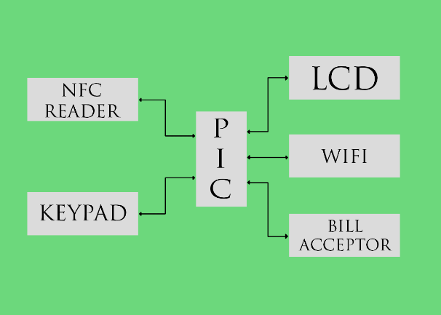

Fig. 1.1. Loading Kiosk System Design

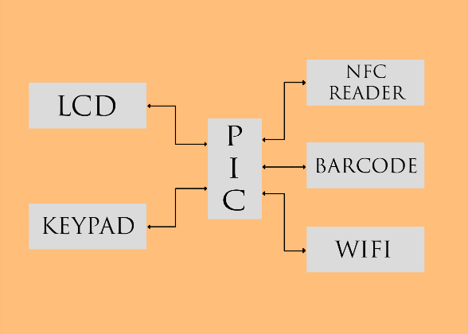

Fig. 1.2. Vendor System Design

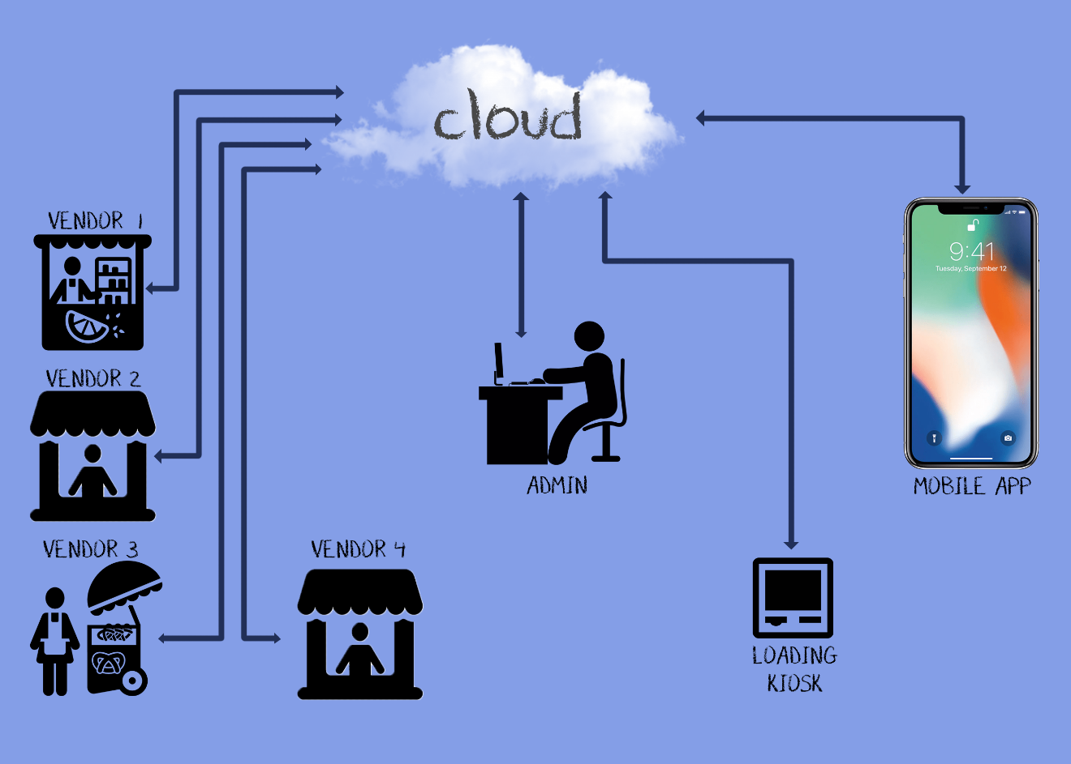

Fig. 1.3. SMART Payment System – System Design

**ESP8266 Wi-Fi Module**. This device will be used to connect the pic to the cloud. It will serve as the communication between the cloud and the microcontroller.

**Barcode Scanner**. It will be used to read the barcodes of the products found in the USLS – IS cafeteria.

**Bill Acceptor**. This will be used in the loading machine to accept the peso-bills.

**PIC Microcontroller**. The PIC Microcontroller will control all hardware devices.

**4x4 Keypad Module**. This will be used for the input in the vendor and loading kiosk.

**Personal Computer**. This will be used by the administrator to host the cloud server.

**Software Development**

**Embedded Software**. The vendor’s transaction system will be programmed using the flowchart in Figure 4.

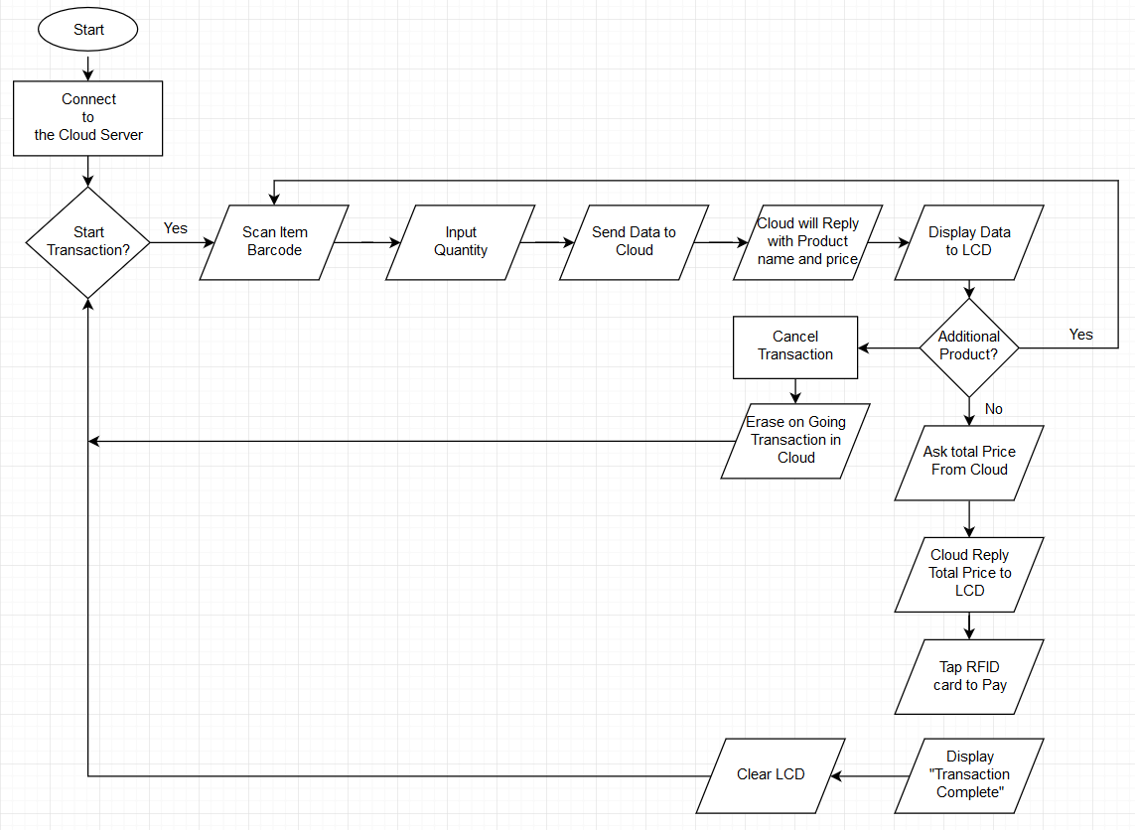

Fig. 2.1 Transaction Flowchart on the Vendor

On the other hand, the loading kiosk will have a program that follows the flowchart in Figure 5.

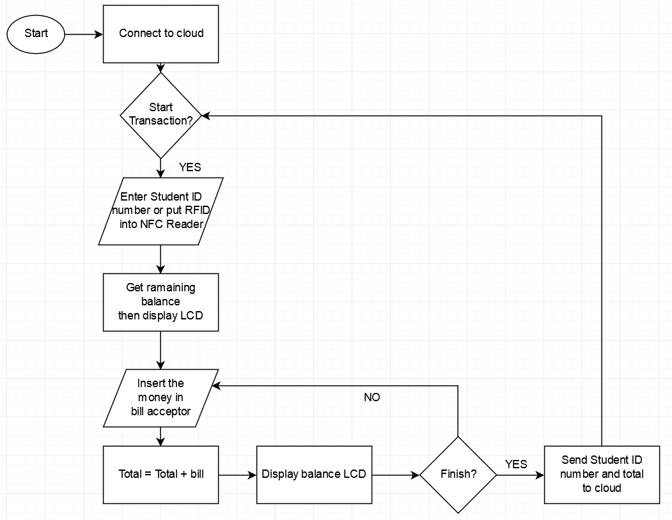

Fig. 2.2 Loading Transaction Flowchart

**Cloud**. It is where transactions are processed and data is stored.

**Mobile Application**. This will be an app provided for the parents where they can monitor the transactions made by the student and limit the child’s daily expenditures.

**REFERENCES**

Avram, M. J. (2014). Advantages and Challenges of Adopting Cloud Computing from an Enterprise Perspective, Retrieved from: <https://www.sciencedirect.com/science/article/pii/S221201731300710X>

Cameron, P. (2018). Advantaged of Automation, Retrieved from: https://www.helpsystems.com/resources/guides/automated-operations-5-benefits-your-organization

French National RFID Center. (2018). How NFC Works, CNRFID, From Innovation to Deployment of RFID and NFC Solutions, Retrieved from: http://www.centrenational-rfid.com/h.ow-nfc-works-article-133-gb-ruid-202.html

Gloag, D. (2018). Mobile App: Definition, Development and Management, Retrieved from: https://study.com/academy/lesson/mobile-app-definition-development-management.html

Herron, D. (2015). Systems and Methods for Individualized Customer Retail Services Using RFID Wristbands. Retrieved from: https://patents.google.com/patent/US20150083803A1/en

Liu, R., Lin, S., & Hubbard, B. (2015), Utilizing RFID Technology in Chinese Power Grid Logistics Management, Yarlagadda, P., Proceedings of the 3rd International Conference on Material, Mechanical and Manufacturing Engineering.

Marian, P., (2015). ESP8266 Datasheet, Electro Schematics, Retrieved from: <https://www.electroschematics.com/11276/esp8266-datasheet/>

Orozco, J. (2014). Mobile Application for Monitoring and Managing Transactions Associated with Accounts Maintained at Financial Institutions Retrieved from: https://patents.google.com/patent/US20140046830A1/en

Purwaningsih, M. (2014). Micropayment Design System Using Near Field Communication Technology (NFC), Retrieved from: http://repository.perbanas.id/xmlui/handle/123456789/1341

Ryan, V. (2017), What Is A Pic Microcontroller? What Can It Do? , World Association Technology Teachers, Retrieved from: http://www.technologystudent.com/pics/picgen1.html

Rouse, M. (2015). Vendor, TechTarget, Retrieved from: https://whatis.techtarget.com/definition/vendor